Mini Music
For Children with Special Needs and Their Families
(18 months – 3 years)
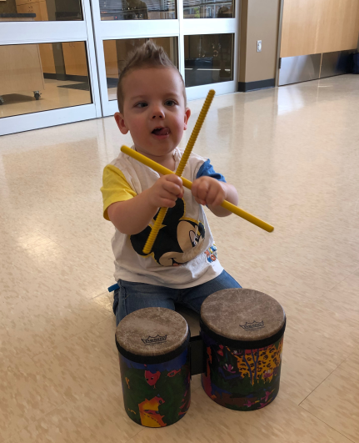
Dates: Wednesdays; May 6, 13, 20, 27 and June 3, 2020

Time: 10:15 am – 10:45 am

Location: Family Centre Westmount
1019 Viscount Road, London
(Attached to Jean Vanier Elementary School)

Cost: None

Register: Online at https://minimusicspring2020.eventbrite.ca

Questions: Please contact Sasha Chircoski, TVCC Therapeutic Recreation,
519-685-8700 ext 53396 or sasha.chircoski@tvcc.on.ca.

Additional Information: If you are unable to register online, call Carrie Connell at 519-685-8700 ext. 53376. After registration, a Recreation Therapist from TVCC will call you to explore your child’s strengths/abilities and share information about the program.

Please note: Siblings ages 18 months - 3 years may register to participate with their family; however, these spaces are limited.
Mini Music is a fun, interactive program for children with special needs and their parent/caregiver. Music can have power and meaning beyond words and supports children’s early learning. Join us for music and movement activities including traditional rhymes, songs, musical stories while also exploring instruments and musical props. Come share the special language of music through a variety of media and gain ideas to enhance music in the home. This is a play based program with supportive TVCC therapists and Family Centre Westmount facilitators.
*Stay for an extra 30 minutes after the program and enjoy some free play activities in the playroom lead by La Ribambelle (French Language).

